C6 AES Support in XmppSDK Eng Spec
Revision History
Rev. | Date | Authors | Description
1.0 | 2009-2-24 | Nick Xiao | Initial Draft
1.1 | 2009-2-27 | Nick Xiao | Add use case 3, 4
1.2 | 2009-3-3 | Nick Xiao | Add encrypted stanza,  Performance consideration
1.3 | 2009-3-3 | Nick Xiao | Add more use cases
1.4 | 2009-3-7 | Nick Xiao | Add file transfer cases
1.5 | 2009-4-28 | Nick Xiao | Add enable AES sequence  Add XmppSDK class model

Content
This document describes the details of AES support in XmppSDK.

Terminology
Upper Layer, all logical layers above the XmppSDK in Connect rich client. Upper layer calls XmppSDK to fulfill user’s various requirements on Xmpp, including AES support.

Interface
interface IXmppInstantMessage : IUnknown
{
HRESULT Start([in] BSTR bstrSessionName, [in] /*ConIMSessionType*/ long eXmppImSessionType, [in] VARIANT_BOOL bEnableAes);
HRESULT Invite([in] BSTR bstrSessionName, [in] BSTR bstrBuddyName, [in] BSTR bstrInviteMsg, [in] BSTR bstrUserData);
HRESULT EnableAes([in] BSTR bstrSessionName, [in] VARIANT_BOOL bEnabled);
HRESULT IsAesEnabled([in] BSTR bstrSessionName, [out] int* nEnableStatus);
};

interface _IXmppInstantMessageEvents : IUnknown
{
HRESULT OnGroupChatError([in] BSTR bstrSessionName, [in] /*ConErrorCode*/ long eResult, [in] BSTR bstrParam);
HRESULT OnAesEnabled([in] BSTR bstrSessionName, [in] VARIANT_BOOL bEnabled, [in] long eResult);
};

Overview
For IM AES support, upper layer SHOULD call IXmppInstantMessage::EnableAes to establish AES. XmppSDK would fire an event of _IXmppInstantMessageEvents:: OnAesFinished to tell upper layer whether AES is established or not.

When dealing with group chat, first, upper layer SHOULD call IXmppInstantMessage::Start. AES is going to be established when upper layer calls IXmppInstantMessage::Invite. If XmppSDK fails to establish AES with a specific invitee, error would be reported via IXmppInstantMessage::OnGroupChatError.

IXmppInstantMessage::IsAesEnabled returns 3 states: DISABLED, ENABLING, ENABLED.

Encrypted Stanzas
The sender's client would strip off the routing information from a stanza.
Example 1. A Stanza to Send (No Routing)
<message type='chat'>
<thread>act2scene2chat1</thread>
<body>
I take thee at thy word:
Call me but love, and I'll be new baptized;
Henceforth I never will be Romeo.
</body>
<active xmlns='http://jabber.org/protocol/chatstates'/>
</message>
This message is then encrypted and sent in one or more stanzas.
Example 2. Sender sends encrypted data
<iq from='romeo@montague.lit/orchard'
id='xtls_3'
to='juliet@capulet.lit/chamber'
type='set'>
<data xmlns='urn:xmpp:tmp:xtls'>
base_64(TLS-Encrypted-Message)
</data>
</iq>

Enable AES sequence
Below is the sequence for enabling AES.
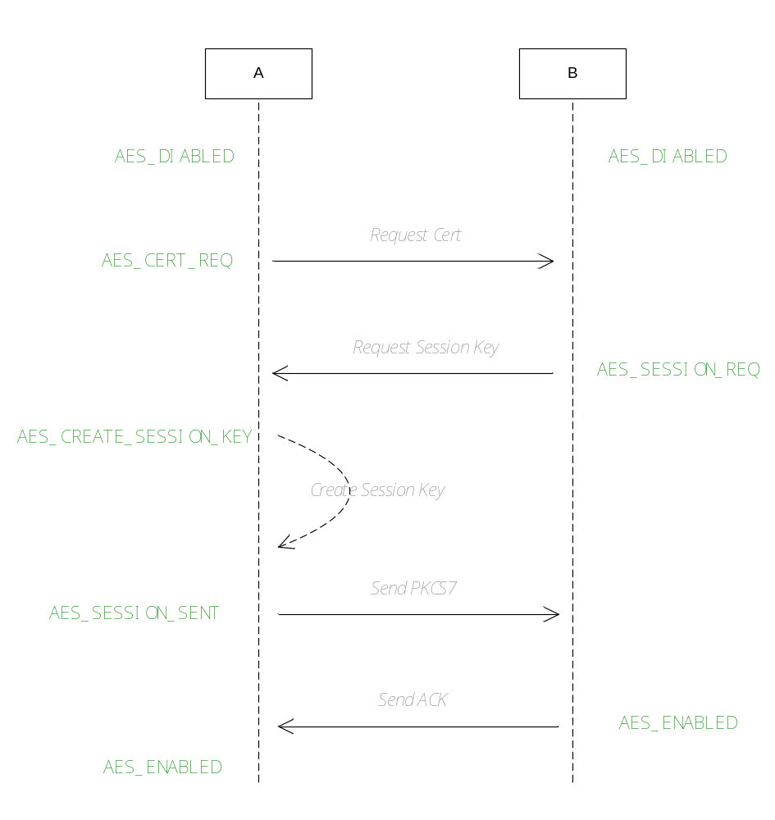
When enable AES for a groupchat, assume A is the starter, B is the invitee.
When enable AES for an IM, assume B is starter, A is the peer. That means, cert request is not needed in this case.

XmppSDK Class Model
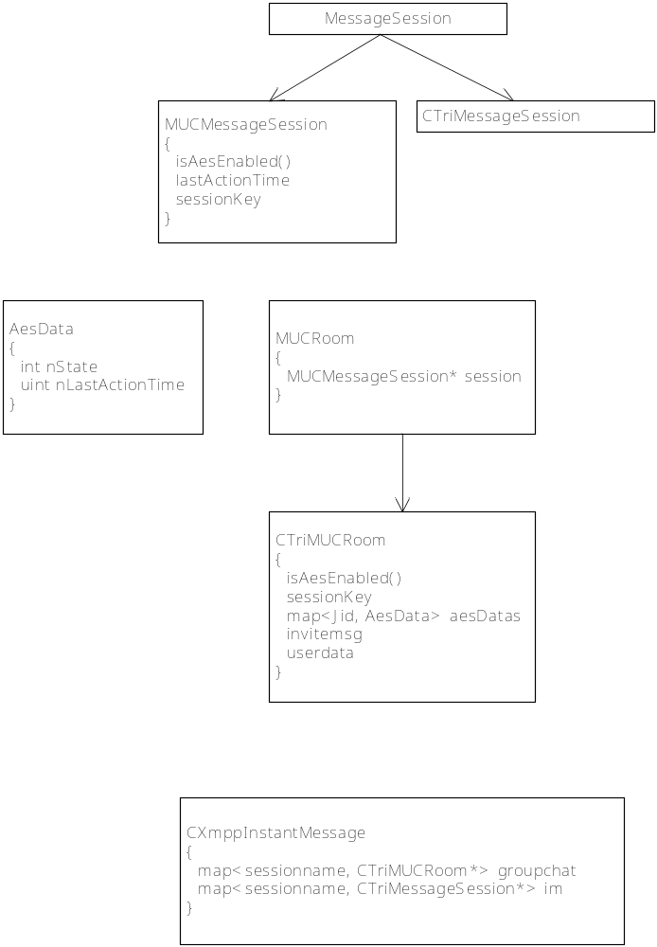

Use cases

Initialization
After client starts, Webex CA certificate and User certificate should be ready. If not, client should call WAPI ExportWebExCertificate and/or SignCSR to get CA cert and user cert respectively. Once both certs are okay, client should call apHelper_Init() to set both certs to encrypto library, and call IXmppInstantMessage::SetUserCert to set user cert to XmppSDK.

Establish AES for IM
Suppose A want to IM with B, to establish AES, A sends its certificate to B, B gets A’s certificate and verifies its validity, generates a session key, encrypts it along with B’s certificate to make a PKCS#7 envelop and sends it to A. A unfolds the envelop, gets the session key and verifies B’s certificate, and sends an ACK to B, if everything’s okay, AES for IM gets established.

When AES for an IM session is about to be established, XmppSDK SHOULD create the IM session data structure beforehand since AES data is stored in the IM session data structure.

Cannot Establish AES
If AES cannot be established, XmppSDK will notify the upper layer via _IXmppInstantMessageEvents::OnAesFinished, client may show an error message in the UI. Addtionally, all messages buffered by XmppSDK when establishing the AES MAY be returned to Application, and the Application MAY display an error message like the following:

Following messages haven’t been delivered due to security issue (Unable to establish End to end encryption which is required):
I take thee at thy word:
Call me but love, and I'll be new baptized;
Henceforth I never will be Romeo.

Note: XmppSDK will try to establish AES again when user sends more messages.

Establish AES for File Transfer
AES for File Transfer is somehow similar with AES for IM. If upper layer wishes to transfer a file secured by AES. Upper layer SHOULD call EnableAes first, then XmppSDK will follow the steps in section “Establish AES for IM” to establish AES. Once AES is established, user can send the file securely.

Send a message when establishing AES
XmppSDK SHOULD hold the message until AES established, encrypts message with the session key and then send the encrypted message.

Transfer a file when establishing AES
Before starting to transfer a file, upper layer MAY call EnableAes to establish AES. When AES establishment is not finished yet, upper layer may request to send the file. In this situation, XmppSDK SHOULD hold the request until establishing AES finished. Once AES established or failed, XmppSDK SHOULD deliver the request to peer or report an error to upper layer respectively.

Establish AES for Group Chat
Suppose A wants to start a group chat with B and C, to establish AES, A starts a group chat, and generates a session key, notify upper layer group chat created. Then upper layer sends a request to a invitee, for example, B, for certificate, B sends its certificate upon the request. After verified validity of B’s certificate, A encrypts session key along with A’s certificate to make a PKCS#7 envelop and sends it to B. B unfolds the envelop , gets the session key and verifies A’s certificate, and sends an ACK to A, if everything’s okay, A invites B into the group chat. Now A repeats the same steps with C.

Receive an encrypted msg but session key unavailable
If client received an encrypted IM message but found no session key available to decrypt it, client caches the message, if AES isn’t being established, follows the steps in Use Case 2, once the AES establishing is done, use new session key to decrypt all cached message.

AES not required, but session key available
When sending a message with AES disabled, but there’s a session key available, client will send the message without encryption ignoring the session key.

Note: This case may occur in the following scenario,
  - A established AES with B
  - B changes its policy somehow to SSL_ONLY.
  - A recalculate the policy requirement, and decide to disable AES. XmppSDK won’t delete the session key, caches it for performance consideration.
  - A sends a message to B

Performance Considerations

Cache Session Key
IM: IM session key has been stored in IM Session. It won’t be cleared even after IM stopped (user closed the IM window), IM session key is cached for later use.

Group Chat: Group chat session key gets cleared after group chat stopped. There’s no session key cache mechanism for group chat.

